Using a Biomek 2000 Hardware and Troubleshooting
Thomas Hunt
What you need:
- A Biomek 2000
- A Computer that uses Windows XP
  - Windows 7 has worked but can behave erratically
  - Anything more advanced will confuse the Biomek 2000
- A double female RS232 Cable
- A power cable
- The Bioworks program installed on your Windows XP
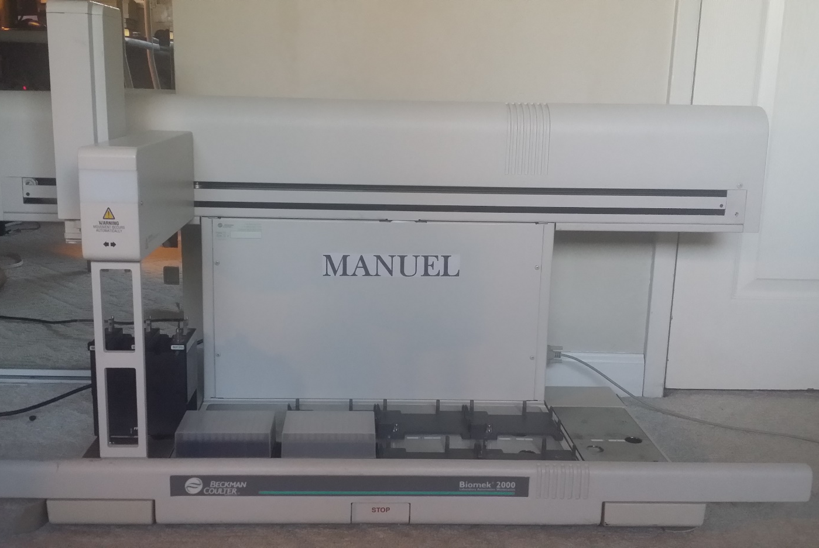
This is Manuel, the Biomek 2000. He pipette liquids at µL level accuracy as well as move lab equipment. This allows him to automate your assays quickly and accurately. He’d love to help you out so he asked me, to create a series of documents. These documents will discuss how to create and use methods, a basic overview of the tools and software, as well as a troubleshooting guide.
The tools of the Biomek 2000
- The Biomek 2000 has a Variety of tools that attach to its arm
- Pipettes attach to the arm and pick up pipette tips on the deck, the Biomek uses a rod in the arm to create suction in the pipette, there are various pipettes that can be used, some can even use 8 pipettes at a time
  - P1000
  - P200
  - MP200
  - P20
  - MP20
- Wash tools are like pipettes, as they aspirate and dispense liquid, however they do not use suction from the arm, and aspirate and dispense separately. The WASH-8 uses tubing which connects to pumps which either dispense liquid from a flask, or aspirate liquid
  - WASH-8
- Gripper picks labware up from the deck and moves it. It can also pick up lids only

