Using a Biomek 2000 Running an Assay and BioScript
Thomas Hunt
What you need:
- A Biomek 2000
- A Computer that uses Windows XP
  - Windows 7 has worked but can behave erratically
  - Anything more advanced will confuse the Biomek 2000
- A double female RS232 Cable
- A power cable
- The Bioworks program installed on your Windows XP
Running an Assay
- When you want to run an assay click on the run program
  - Important! Be sure the Workstation server is already open and is fully connected to the Biomek 2000. If not, the Biomek will complain.
- 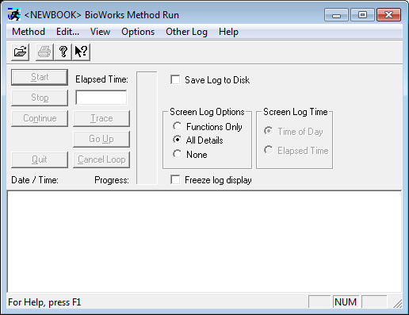
- Once this is pulled up, click on the open methond icon
- 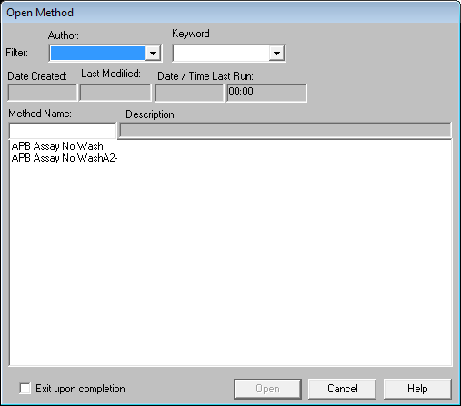
- Note that the correct Lab Book must be active when you run a program, if you’re method is saved in another lab book, you must close run, open Lab Book Manager, and switch to the correct Lab Book before continuing
- Select your saved assay and click open
- Then press start on the run folder
- 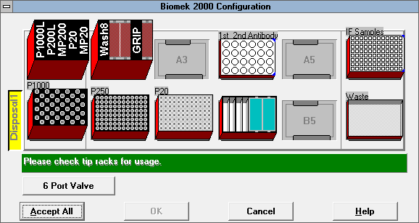
- After you press run, this window will pull up, it’s reminding you what the configuration on the deck should be.
- I highly recommend double checking everything on the deck. This includes:
  - Lids are on if they’re supposed to or off if they’re supposed to
  - The right liquids, plates and tools are in the right location
  - The 6 port valve has the right liquid for the right valve
- Be thorough! You don’t want any nasty surprises halfway through the process.
- Once you click Accept all, sit back and enjoy the power of the machine
BioScript
- The past actions the Biomek has performed so far have all been rather controlled, they’re very specific with limitations. For most lab procedures, this is enough. However, for specialized assays, there is a “freestyle” in which the user directly controls where and how much the Biomek 2000 moves. These movements can be saved and inserted into a method later. BioScript can be tricky and less used, but can come in handy.
- Like Run, be sure to have the Workstation Server open and connected to the Biomek 2000
- The Biomek will turn on, home itself, and then be ready for commands
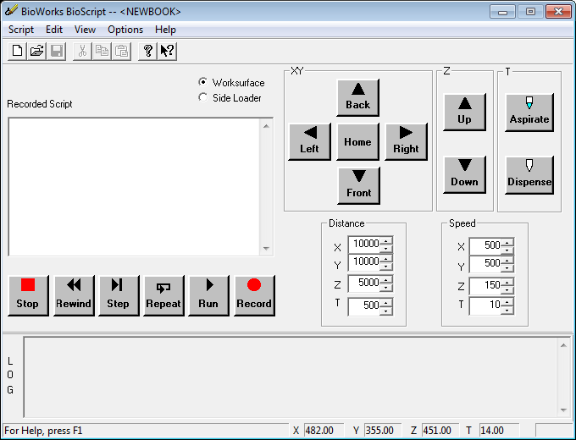
- The Back and Front move the Y axis
- The Left and Right move the X axis
- The Up and Down move the Z axis
- The Aspirate and Dispense move the T axis
- Both the distance and speed for each axis is adjustable
- Record logs all the actions on a coded script, you can turn this on or off
- You can either write the script in the recorded script or write the commands yourself while recording
- When writing script, the AX, AY, AZ and AT define the speed of the axis
- The move command uses MV to define a distance while MA defines the location the arm will move to
- Each line is written like this
  - ME 49200 35500 45100 1400
  - Note there is no period to separate the tenths and hundredths place
- Once you have completed filling the Recorded Script, you can save this and add it to a Bioworks method later.

