Using a Biomek 2000 Configuration
Thomas Hunt
What you need:
- A Biomek 2000
- A Computer that uses Windows XP
  - Windows 7 has worked but can behave erratically
  - Anything more advanced will confuse the Biomek 2000
- A double female RS232 Cable
- A power cable
- The Bioworks program installed on your Windows XP
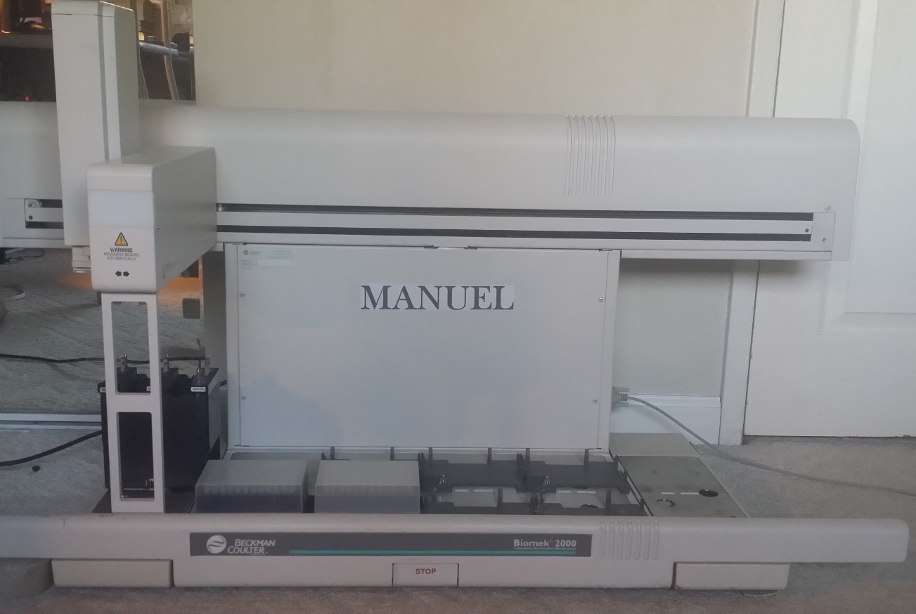
Over time, the Biomek 2000 will need to be configured to keep it accurate. Here are a variety of adjustments I do to keep the Biomek 2000 in shape.
- Be sure the Workstation server is on and connected to the Biomek before you begin the diagnostics
- Before you begin configuration, clear the deck of the Biomek 2000. It’s a good safety precaution and it may get in the way
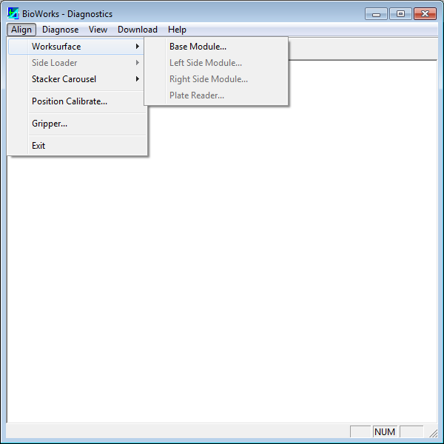
- All adjustments will be done on Diagnostics. Click on the Diagnostics icon and select align, then position calibrate
  - The Biomek will automatically move on its axis, calibrating itself.
  - The test should be successful, if not, repeat the calibration test.
- The next calibration used is the alignment of the base, left side and right side module. It uses the red alignment probe to align with a labware holder
- Click on align, worksurface then either Base module, left side module or right side module
- Base Module
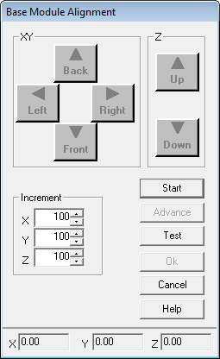
- Before beginning, clear the worksurface and place the labware holders on the following locations: A2, B2, B5 and A5
- To begin the alignment, press start. If you only want to confirm the configuration authenticity, press test instead, it’s a lot shorter
- Now, the Biomek 2000 will ask you to clear the lab surface, and place the lab holders on the correct location
- Next attach the red alignment probe. First, add a 20 mL pipette tip to the probe, make sure it’s straight. Then slide the probe into the arm of the Biomek, where most tools attach. Make sure the arrow labeled front is pointed toward the front of the Biomek 2000. It will not slide all the way in. There is a locking mechanism that can be manually opened by pushing the black rectangular button found at the bottom front of the biomek 2000 arm. Make sure it is securely fastened before continuing
- The Biomek 2000 will move over holes found in the labware, using the Diagnostics program you will move the arm until it is aligned with the hole and barely in, to test if it’s barely in, slide a piece of paper through it.
- Once the test is done, click OK, you have finished aligning the Base module.
- The left and right side are the same, but use labware holders on either A1 and B1 or A6 and B6.
  - Also they will hover over a location that does not have a hole to test the y axis all you have to do, is make sure it is barely touching the surface

